**LAB-6**

**WEB TECHNOLOGY**

**NAME**:ELLURU AMRUTHA

**REDG NUMBER** : 21BCE8405

**1. Design a web page to use various filters in PHP for server-side validation.**

**a. Validate an integer**

**b. Validate a float variable**

**c. Validate a Boolean variable**

**d. Validate an IP address**

**e. Validate an URL**

**f. Sanitize an integer**

**g. Sanitize an IP address**

**h. Sanitize an URL**

**i. Sanitize a float variable**

**j. Sanitize a Boolean variable**

**CODE:**

**FOR SANITIZATION:**

**Sanitize.html:**

<!DOCTYPE html>

<html>

<head>

<title>PHP Filter Validation</title>

<h1>NAME:ELLURU AMRUTHA </h1>

<h1>RED NUMBER : 21BCE8405 </h1>

<style>

body {

font-family: Arial, sans-serif;

margin: 0;

padding: 0;

background-color: #f2f2f2;

}

.container {

max-width: 500px;

margin: 0 auto;

padding: 20px;

background-color: #fff;

box-shadow: 0 4px 8px rgba(0, 0, 0, 0.1);

}

h1 {

text-align: center;

margin-bottom: 20px;

}

form label {

display: block;

margin-bottom: 10px;

}

form input[type="text"],

form input[type="submit"] {

width: 100%;

padding: 10px;

margin-bottom: 15px;

border: 1px solid #ccc;

border-radius: 5px;

}

form input[type="submit"] {

background-color: #4CAF50;

color: #fff;

cursor: pointer;

}

form input[type="submit"]:hover {

background-color: #45a049;

}

.error-message {

color: #f00;

margin-bottom: 10px;

}

.valid-message {

color: #0a0;

margin-bottom: 10px;

}

</style>

</head>

<body>

<h2>Enter Data to be Sanitized:</h2>

<form action="process_form_1.php" method="post">

<label for="integer_input">Integer:</label>

<input type="text" id="integer_input" name="integer_input" required><br>

<label for="ip_address_input">IP Address:</label>

<input type="text" id="ip_address_input" name="ip_address_input" required><br>

<label for="url_input">URL:</label>

<input type="text" id="url_input" name="url_input" required><br>

<label for="float_input">Float:</label>

<input type="text" id="float_input" name="float_input" required><br>

<label for="boolean_input">Boolean:</label>

<input type="text" id="boolean_input" name="boolean_input" required><br>

<input type="submit" value="Submit">

</form>

</body>

</html>

**process_form_1.php:**

<?php

function sanitize_integer($input_str) {

return preg_replace('/[^0-9]/', '', $input_str);

}

function sanitize_ip_address($ip_address) {

preg_match('/\b\d{1,3}\.\d{1,3}\.\d{1,3}\.\d{1,3}\b/', $ip_address, $matches);

return isset($matches[0]) ? $matches[0] : null;

}

function sanitize_url($url) {

preg_match('/(https?:\/\/\S+)/', $url, $matches);

return isset($matches[0]) ? $matches[0] : null;

}

function sanitize_float($input_str) {

return preg_replace('/[^0-9.]/', '', $input_str);

}

function sanitize_boolean($input_str) {

return strtolower($input_str) === 'true' || strtolower($input_str) === 'yes' || $input_str === '1';

}

// Check if the form was submitted

if ($_SERVER["REQUEST_METHOD"] == "POST") {

// Sanitize the inputs

$sanitized_integer = sanitize_integer($_POST["integer_input"]);

$sanitized_ip_address = sanitize_ip_address($_POST["ip_address_input"]);

$sanitized_url = sanitize_url($_POST["url_input"]);

$sanitized_float = sanitize_float($_POST["float_input"]);

$sanitized_boolean = sanitize_boolean($_POST["boolean_input"]);

// Display the sanitized data

echo "<h2>Sanitized Data:</h2>";

echo "Sanitized Integer: " . $sanitized_integer . "<br>";

echo "Sanitized IP Address: " . $sanitized_ip_address . "<br>";

echo "Sanitized URL: " . $sanitized_url . "<br>";

echo "Sanitized Float: " . $sanitized_float . "<br>";

echo "Sanitized Boolean: " . var_export($sanitized_boolean, true) . "<br>";

} else {

// If the form was not submitted, display an error message

echo "<h2>Error:</h2>";

echo "Please submit the form.";

}

?>

**FOR VALIDATION:**

**Valid_sanitization.php:**

<!DOCTYPE html>

<html>

<head>

<title>PHP Filters</title>

<h1>NAME:ELLURU AMRUTHA</h1>

<h1>RED NUMBER : 21BCE8405</h1>

<style>

body {

font-family: Arial, sans-serif;

margin: 0;

padding: 0;

background-color: #f2f2f2;

}

.container {

max-width: 500px;

margin: 0 auto;

padding: 20px;

background-color: #fff;

box-shadow: 0 4px 8px rgba(0, 0, 0, 0.1);

}

h1 {

text-align: center;

margin-bottom: 20px;

}

form label {

display: block;

margin-bottom: 10px;

}

form input[type="text"],

form input[type="submit"] {

width: 100%;

padding: 10px;

margin-bottom: 15px;

border: 1px solid #ccc;

border-radius: 5px;

}

form input[type="submit"] {

background-color: #4CAF50;

color: #fff;

cursor: pointer;

}

form input[type="submit"]:hover {

background-color: #45a049;

}

.error-message {

color: #f00;

margin-bottom: 10px;

}

.valid-message {

color: #0a0;

margin-bottom: 10px;

}

</style>

</head>

<body>

<div class="container">

<h1>PHP Filters Example</h1>

<form method="post" action="<?php echo htmlspecialchars($_SERVER["PHP_SELF"]); ?>">

<label>Integer:</label>

<input type="text" name="integer_input"><br>

<label>Float:</label>

<input type="text" name="float_input"><br>

<label>Boolean:</label>

<input type="text" name="boolean_input"><br>

<label>IP Address:</label>

<input type="text" name="ip_input"><br>

<label>URL:</label>

<input type="text" name="url_input"><br>

<input type="submit" value="Submit"><br>

</form>

<?php

if ($_SERVER["REQUEST_METHOD"] == "POST") {

// Validate and Sanitize an integer

if (isset($_POST['integer_input'])) {

$integer = filter_var($_POST['integer_input'], FILTER_VALIDATE_INT);

if ($integer === false) {

echo "<div class='error-message'>Invalid integer input!</div>";

} else {

$sanitizedInteger = filter_var($integer, FILTER_SANITIZE_NUMBER_INT);

echo "<div class='valid-message'>Valid integer: " . $sanitizedInteger . "</div>";

}

}

// Validate and Sanitize a float

if (isset($_POST['float_input'])) {

$float = filter_var($_POST['float_input'], FILTER_VALIDATE_FLOAT);

if ($float === false) {

echo "<div class='error-message'>Invalid float input!</div>";

} else {

$sanitizedFloat = filter_var($float, FILTER_SANITIZE_NUMBER_FLOAT, FILTER_FLAG_ALLOW_FRACTION);

echo "<div class='valid-message'>Valid float: " . $sanitizedFloat . "</div>";

}

}

// Validate and Sanitize a boolean

if (isset($_POST['boolean_input'])) {

$boolean = filter_var($_POST['boolean_input'], FILTER_VALIDATE_BOOLEAN, FILTER_NULL_ON_FAILURE);

if ($boolean === null) {

echo "<div class='error-message'>Invalid boolean input!</div>";

} else {

echo "<div class='valid-message'>Valid boolean: " . var_export($boolean, true) . "</div>";

}

}

// Validate and Sanitize an IP address

if (isset($_POST['ip_input'])) {

$ip = filter_var($_POST['ip_input'], FILTER_VALIDATE_IP);

if ($ip === false) {

echo "<div class='error-message'>Invalid IP address input!</div>";

} else {

$sanitizedIP = filter_var($ip, FILTER_SANITIZE_STRING);

echo "<div class='valid-message'>Valid IP address: " . $sanitizedIP . "</div>";

}

}

// Validate and Sanitize a URL

if (isset($_POST['url_input'])) {

$url = filter_var($_POST['url_input'], FILTER_VALIDATE_URL);

if ($url === false) {

echo "<div class='error-message'>Invalid URL input!</div>";

} else {

$sanitizedURL = filter_var($url, FILTER_SANITIZE_URL);

echo "<div class='valid-message'>Valid URL: " . $sanitizedURL . "</div>";

}

}

}

?>

</div>

</body>

</html>

**SCREENSHOT:**

**FOR VALIDATION:**

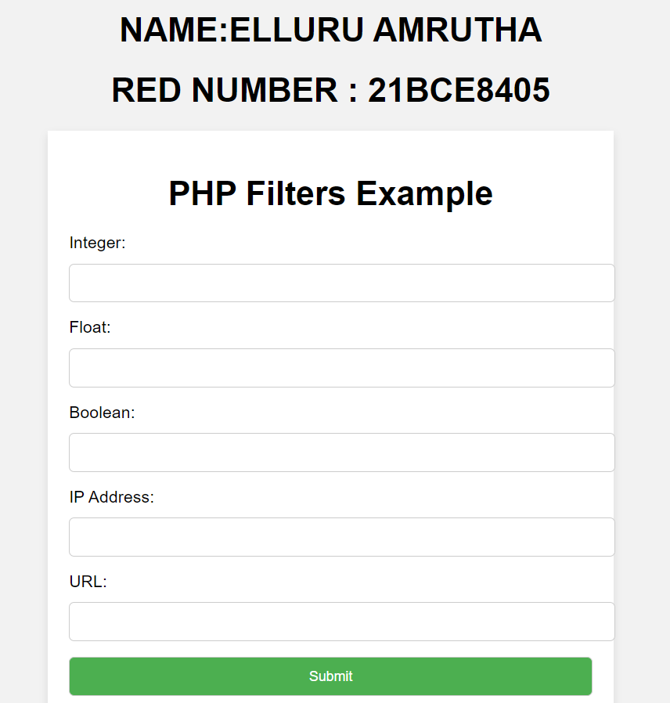

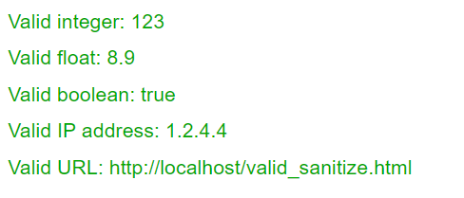

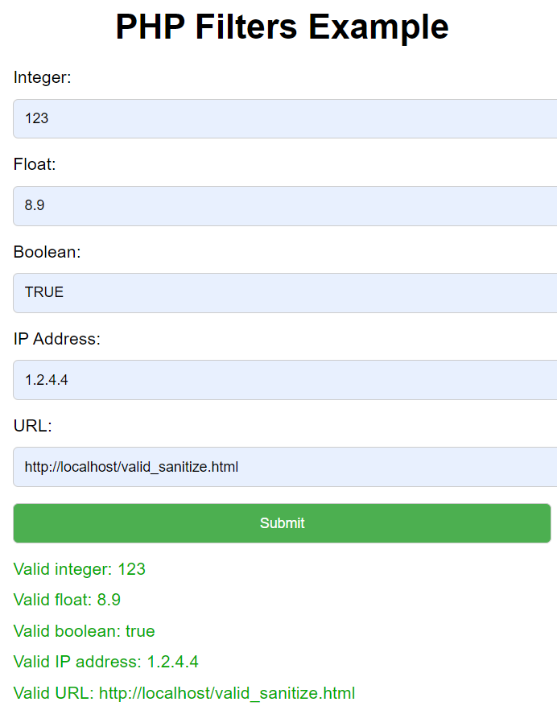

**FOR SANITIZATION:**

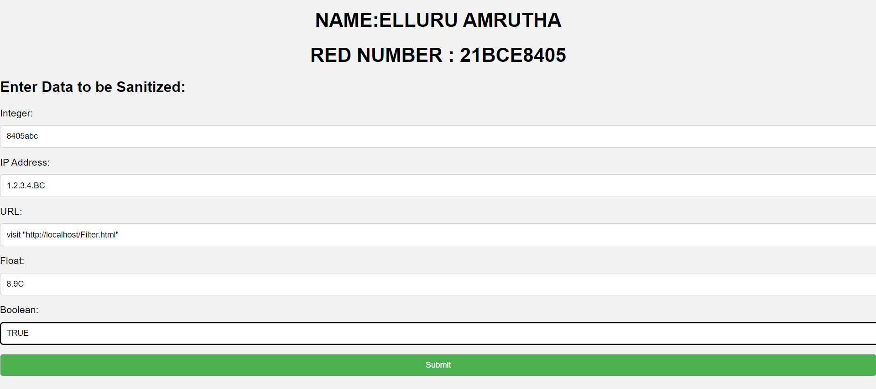

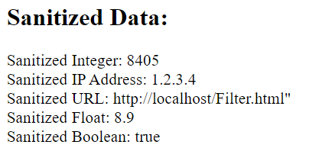

**2. Develop an web page to use various file handling function available in PHP.**

**CODE:**

**file_handler.php:**

<?php

if (isset($_POST["submit"])) {

$file = $_FILES["file"];

// Check for errors during file upload

if ($file["error"] > 0) {

echo "Error: " . $file["error"];

} else {

// Move the uploaded file to a specific directory

$targetDir = "uploads/";

$targetFile = $targetDir . basename($file["name"]);

move_uploaded_file($file["tmp_name"], $targetFile);

echo "File uploaded successfully!<br>";

// File Reading

echo "File Content:<br>";

$content = file_get_contents($targetFile);

echo nl2br($content); // nl2br to preserve line breaks in HTML

// File Writing

$newContent = "This is some new content written to the file.";

file_put_contents($targetFile, $newContent);

echo "<br>New content written to the file successfully!<br>";

// File Appending

$appendContent = "This is additional content appended to the file.";

file_put_contents($targetFile, $appendContent, FILE_APPEND);

echo "Additional content appended to the file!<br>";

}

}

?>

**Index.html:**

<!DOCTYPE html>

<html>

<head>

<title>PHP File Handling</title>

<style>

body {

font-family: Arial, sans-serif;

background-color: #f2f2f2;

margin: 0;

padding: 0;

}

h1 {

text-align: center;

margin: 40px 0;

color: #333;

}

form {

max-width: 500px;

margin: 0 auto;

padding: 20px;

background-color: #fff;

border: 1px solid #ccc;

border-radius: 5px;

box-shadow: 0 2px 5px rgba(0, 0, 0, 0.1);

}

label {

display: block;

margin-bottom: 10px;

font-weight: bold;

color: #555;

}

input[type="file"] {

margin-bottom: 20px;

}

input[type="submit"] {

background-color: #4CAF50;

color: #fff;

padding: 10px 20px;

border: none;

border-radius: 4px;

cursor: pointer;

}

input[type="submit"]:hover {

background-color: #45a049;

}

pre {

max-width: 500px;

margin: 20px auto;

padding: 20px;

background-color: #fff;

border: 1px solid #ccc;

border-radius: 5px;

box-shadow: 0 2px 5px rgba(0, 0, 0, 0.1);

white-space: pre-wrap;

font-weight: bold;

color: #333;

}

.success {

color: #4CAF50;

font-weight: bold;

}

.error {

color: #f44336;

font-weight: bold;

}

</style>

</head>

<body>

<h1>File Handling in PHP</h1>

<form action="file_handler.php" method="post" enctype="multipart/form-data">

<label for="file">Select File:</label>

<input type="file" name="file" id="file">

<input type="submit" value="Upload File" name="submit">

</form>

</body>

</html>

**SAMPLE.TEXT:**

NAME : ELLURU AMRUTHA

REDG NUMBER : 21BCE8405

**SCREENSHOT:**

